File permissions in Linux

Project description

In this project I used Linux commands to examine existing permissions on the file system. To ensure the security of the system I need to check the permissions to make sure it matches the correct authorization, and then modify these permissions to authorize appropriate users and remove any unauthorized access.

Check file and directory details

To check the file and directory details I used “ls -l”. This will show you the permissions for each file in the designated directory for the user, group and others (note this does not show hidden files, I used “ls -la” later to examine the hidden file permissions). Initially the permissions are as follows:

Drafts directory → user had read, write and execute permissions, group had execute permissions and others had no permissions.

Project_k.txt file → has read and write permissions for user, group and others

Project_m.txt file → user has read and write permissions, group has read permissions, others have no permissions

Project_r.txt file → users and groups have read and write permissions. Others have read only permissions.

Project_t.txt file → users and groups have read and writer permissions. Others have read only permissions.

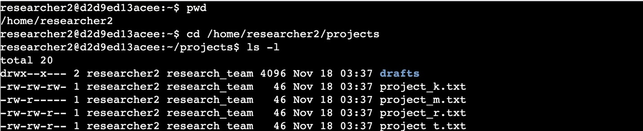

Describe the permissions string

So for “drafts” the 10 character string is drwx–x—. This string is used to convey different information about these permissions. The first letter is used to describe the file type. “d” represents that “drafts” is a directory. The next 3 letters are the permissions allowed for the user, the following 3 are permissions allowed for the group and the last 3 are permissions allowed for others. “r” indicates read permissions, “w” indicating write permissions and “x” indicating execute permissions. If there is a “-” that means the user does not have the indicated permission(s). In this example we can see the user has read, write, and execute permissions. The group only has execute permissions and others have no permissions at all.

Change file permissions

I noticed that project_k.txt had write permissions for other so I typed in “chmod o-w project_k.txt” to remove the permission.

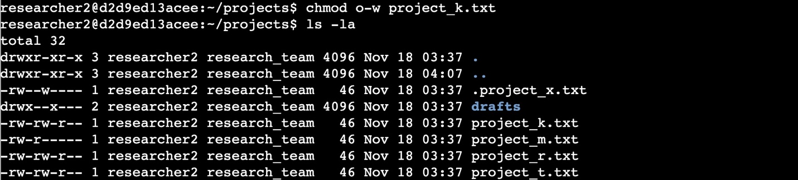

Change file permissions on a hidden file

In order to find the hidden files first I typed in “ls -la” and noticed the user and group both had write permissions. To remove them I type in “chmod u-w .project_x.txt” & “chmod g-w .project_x.txt”.

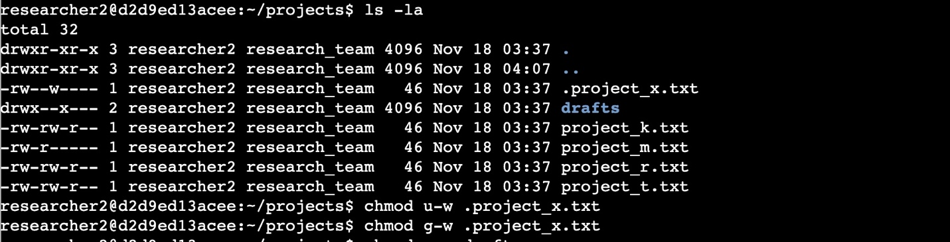

Change directory permissions

I used “chmod g-x drafts” to remove group access to the drafts directory. Now only the user has permissions to access this directory.

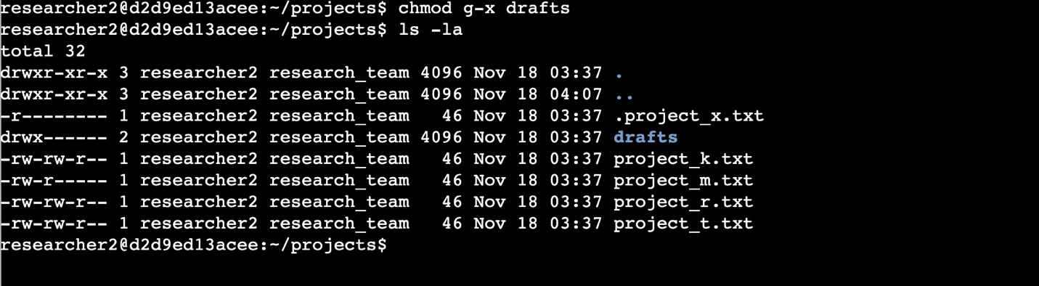

Summary

After reviewing I noticed a few of the permissions were incorrect and I used Linux commands to modify these permissions. I removed write permissions for the user and group in .project_x.txt as well as removing write access for other in project_k.txt. I then used “ls -la” at the end to verify that I had modified the permissions correctly.